Introduction to AI Ngwepe FM

1. **What is Artificial Intelligence**

Artificial intelligence (AI) may be defined as the branch of computer science that is concerned with the automation of intelligent behaviour.

1. **Turing test**

**Definition:**  
The **Turing Test**, proposed by **Alan Turing** in 1950, is a test to determine whether a machine can mimic intelligent behaviour indistinguishable from that of a human.

**Purpose of the Turing Test**

* To answer the question: "Can machines think?"
* To test artificial intelligence by evaluating a machine’s ability to exhibit human-like intelligence in conversation.
* Involves **three participants**:
  + **Human interrogator (judge)**
  + **Human respondent**
  + **Machine (AI)**
* The communication is text-based to avoid clues from speech or appearance.
* The interrogator interacts with both the human and the machine but doesn’t know which is which.
* If the interrogator **cannot reliably distinguish** the machine from the human, the machine **passes the test**.

1. **Proposition to Predicate Calculus (First-Order Logic)**

**Definition**

**Predicate Calculus** is a formal system in logic used to express statements involving objects, their properties, and relationships between them.

A **predicate** is a function. It takes some variable(s) as arguments; it returns either True or False (but not both) for each combination of the argument values.

3 + 2 = 5 is a proposition. *But is X + 2 = 5 a proposition*?

Because it has a variable X in it, we cannot say it is True or False. So, it is not a proposition. It is called a predicate.

**Predicate Calculus** Extends **Propositional Logic** by including:

* + **Quantifiers**
  + **Variables**
  + **Predicates**
  + **Functions**
  + **Domains**

A few things that are difficult to express using propositional logic:

* Relationships among individuals: Alice is a friend of Bob and Alice is not a friend of Cate.
* Generalizing patterns: Every bear likes honey.
* Infinite domains: Define what it means for a natural number to be prime.

**Propositional Calculus**

Consider the following example:

“On even weekdays, if the sun is out and there are no clouds, I am sad. If the sun is out then there are no clouds. Since I am always Happy, and I live on a planet where all weekdays are even, it is never sunny on my planet”

*--Pay attention to negations--*

The intention of this bizarre paragraph is to emphasis that we do not care if the premises are realistic or true. Instead, we are interested in the logical structure of the paragraph, and the ability to analyse its logical validity.

Let us start by removing all the non-logical content from the paragraph by replacing pieces of information with letters which are called atomic formula. For this we define a dictionary which permits the translation:

(1) A = “It is an even day”.

(2) B = “the sun is out”.

(3) C = “There are no clouds”.

(4) D = “I am sad”.

We can now reformulate the paragraph:

Premise 1: “If A, then if B and C, then D.

Premise 2: If B then C.

Premise 3: Not D and A.

Conclusion: Not B.

Finally let us turn the premises and conclusion to be purely symbolic, for this we need the Logical connectives:

(1) A and B is denoted by A ∧ B. (Conjunction)

(2) A or B is denoted by A ∨ B. (Disjunction)

(3) If A then B is denoted by A ⇒ B. (Implication)

(4) Not A is denoted by ¬A. (Negation)

Finally, our initial paragraph has the following symbolic representation in propositional calculus:

Premise 1: A ⇒ ((B ∧ C) ⇒ D)

Premise 2: B ⇒ C

Premise 3: (¬D) ∧ A

Conclusion: ¬B

Propositional calculus logical identities:

(1) **Commutativity:**

(a) A ∧ B ≡ B ∧ A.

(b) A ∨ B ≡ B ∨ A.

(c) A ⇒ B ≡ B ⇒ A.

**(2) Associativity:**

(a) A ∧ (B ∧ C) ≡ (A ∧ B) ∧ C.

(b) A ∨ (B ∨ C) ≡ (A ∨ B) ∨ C.

**(3) Distributivity law:**

(a) A ∧ (B ∨ C) ≡ (A ∧ B) ∨ (A ∧ C).

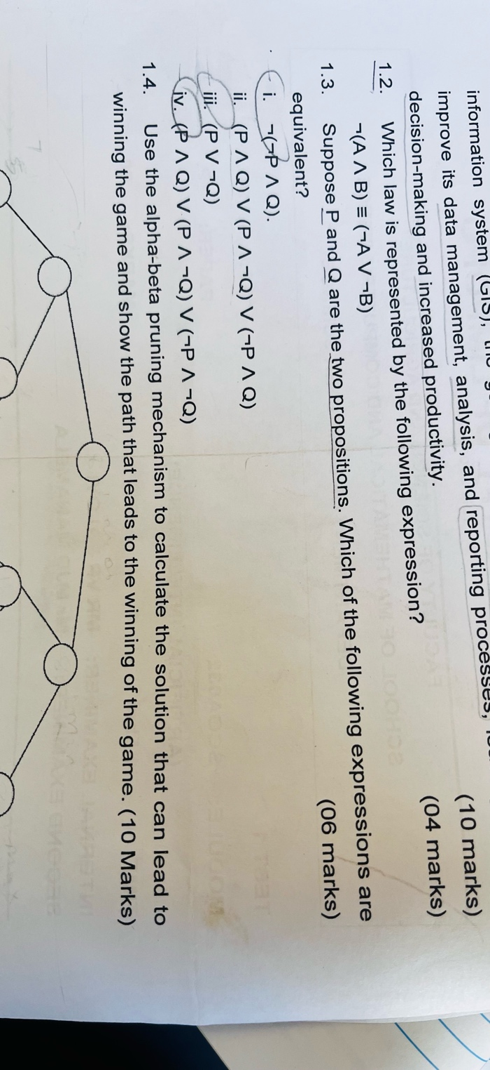(b) A ∨ (B ∧ C) ≡ (A ∨ B) ∧ (A ∨ C).

**(4) Implication identities:**

(a) A ⇒ B ≡ (¬A) ∨ B.

(b) A ⇒ B ≡ (¬B) ⇒ (¬A). (contrapositive)

**(5) Law of negation of logical connectives:**

(a) ¬ (¬(A)) ≡ (A).

(b) ¬ (A ∧ B) ≡ (¬A) ∨ (¬B). (De-Morgan law I)

(c) ¬ (A ∨ B) ≡ (¬A) ∧ (¬B). (De-Morgan law II)

(d) ¬ (A ⇒ B) ≡ A ∧ ¬B.